Computer Systems and Internet Technologies - COMP1589

Layouts & Data Posting
Lab

SUMMARY
In this lab you will be given some examples of different approaches to layouts, and then asked to apply these to a pre-built form. After that you will be using JavaScript to send the form data to a remote endpoint using AJAX (XMLHttpRequest).

OBJECTIVES
- To be confident with the use of layout systems
- To become familiar with interacting with form data
- To be introduced to sending form data to a remote resource

TASK 1 - Layout
For this task download the zip file below and extract all elements of it to a new folder before using it. Then open this folder in Visual Studio Code.
DOWNLOAD ME
Step 1
Get familiar with the various layout options in CSS & HTML, to do this open the file “layouts.html” in Visual Studio Code and also in your browser (I advise Chrome). Have a read through the code, inspect the various layouts using Dev Tools and have a go at changing elements of the code to see the impact the layouts have.
Step 2
When you are comfortable with the various layout options and features you can then open the file “form.html”, open this in your browser and Visual Studio Code.
You should see something like this:
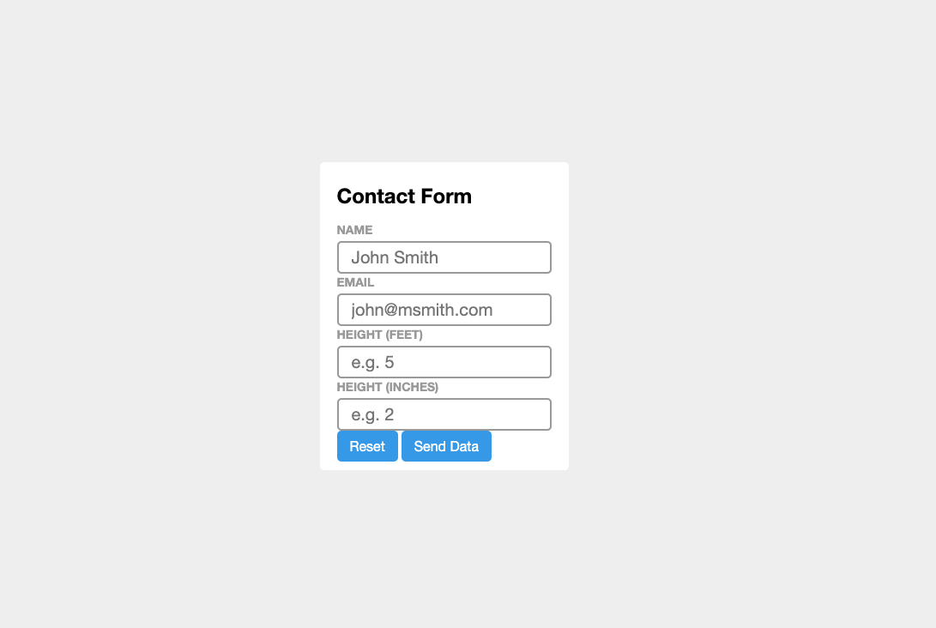

Step 3
Now we want you to update the CSS only to fix the layout above, taking it from a single column to a multi-column layout that should look like this:
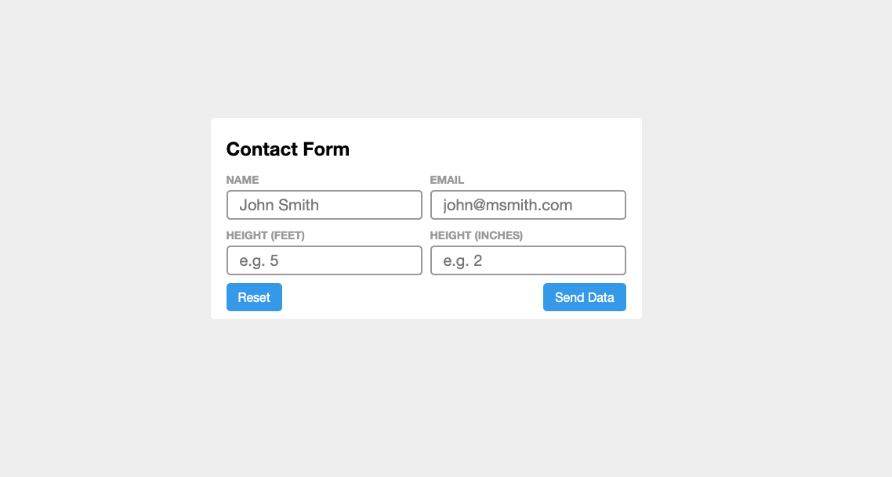
To achieve this you will simply need to update the provided CSS selectors in your file, specifically the:
- Form selector
- .row selector
- .row-apart selector
The attributes are already there for you, all you need to do is update them to the correct values. I’d suggest the quickest way of doing this is using web inspector and changing the CSS in the dev tools rather than in your code, once you find the right combination you can then add it to your code.

Solution
If you have managed that you should have a solution that looks something like this, if you don’t that’s fine if you’ve still got it to look how you want - there are many approaches to solve the problem.
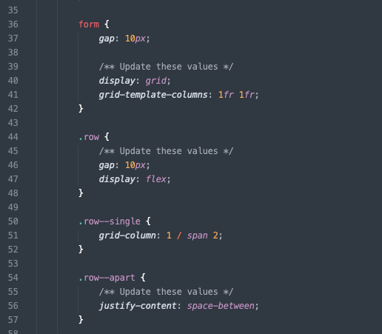

TASK 2 - JS Form Submission
In our previous labs we looked at preventing our form from sending and validating its data. Now we will look at the next step from this, when we wish to send our data. There are two ways to do this, one is simply allowing the browser to take back control and send the data as per the form attributes, the other is using a system referred to as AJAX (technical name is XMLHttpRequest).
Step 1
Open your “form.html” file from the first task, you should see this has some JS at the bottom of it. In the browser, where you have the form.html file open, open your dev tools and navigate to the console and then press the submit button on your form to see what happens - you should see that nothing happens.
Step 2
Your code is incomplete and this is why nothing happens, to get started you need to add your form selector and event listener - you can see we’ve provided the base of the code for this, you just need to fill it in.
Areas you need to complete are identified with “FILL_ME_IN”.
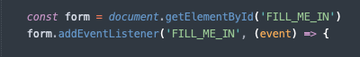
If you get stuck please ask for help, use online documentation such as mdn web docs or W3School, and refer to previous lab tasks.

Step 2 - Solution
Your code should now look something like this; we have entered our ID for our form, and are listening to the form’s “submit” event. See the code below.
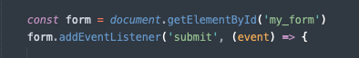

Step 3
Now when you submit your form you should have a “Form Submitted” message in your console, but also an error message - something like this.
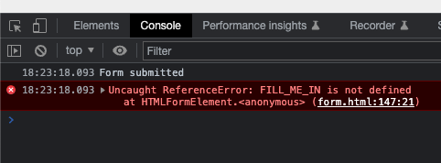
The reason we are getting an error here is because we haven’t updated our function call to the correct function name, give this a go now and if you get stuck please ask.
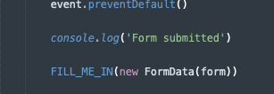

Step 3 - Solution
Your code should now look something like the below, this is because we have updated our function call to our named function “processForm”.
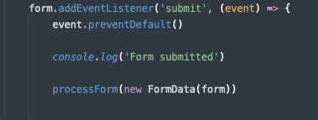

Step 4
Now when we submit our form we will get an error message about CORS (this is a security system in the browser, Cross-Origin Resource Sharing (CORS) - HTTP | MDN) and a failure message.
This is because we haven’t tied up our function to our remote source, before we do this let’s look over our function code.
The first thing we can see is that we are provided with data from our function call, this is put into our named argument “FD”. You can see below where we send our data to our method, this data is our “FormData” object.
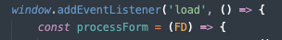
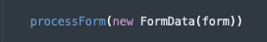
The next line you see is creating an instance of the XMLHttpRequest object, this is a browser API that allows us to send HTTP Requests to remote sources - specifically we would use this sending data such as that gathered in forms. We assign this instance to our variable that we’ve named “XHR”.
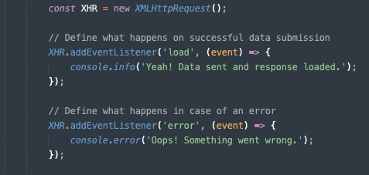
After this we then assign our event listeners, the two we care about right now are the “load” event and the “error” event. The load event is triggered when a response is loaded from the server that we are sending the data to, this isn’t always a good response but it shows we have a response. The error listener is the inverse, when we either get no response back or a bad response from the server (this could indicate a server error).
Finally we then open a connection to our remote source via its URL and then send our data; when using a FormData object we can send that as it is and the browser will handle everything else. If we don’t use a FormData object we then have to build our own content to send.
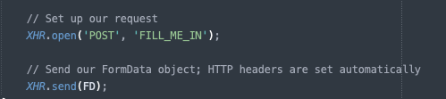
Step 5
We can now add our final step to our build by giving our code somewhere to send our data, for this we will use a free testing service but in real life you would be using a server that will then process the data.
First of all visit https://beeceptor.com/ and enter a name for your “endpoint”, this can be anything you want, and click “Create Endpoint”
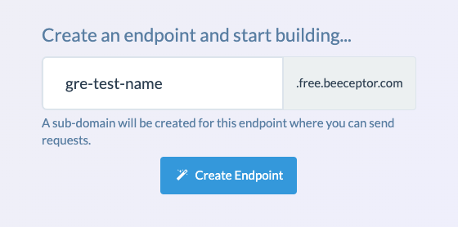
You’ll now see something like this:
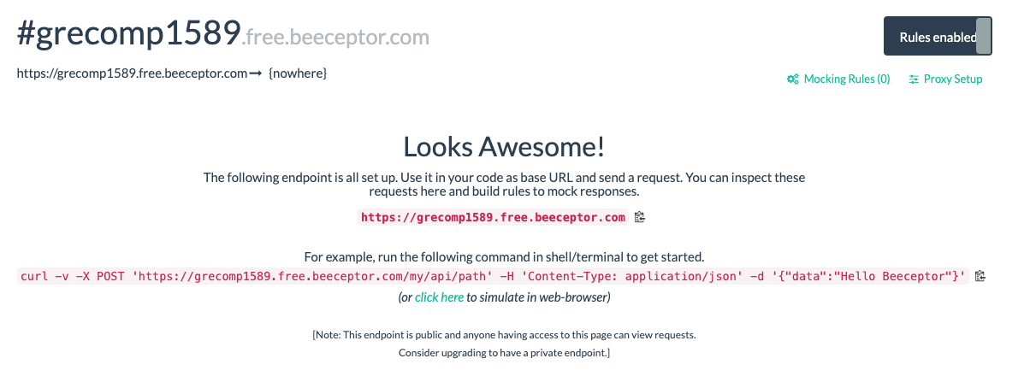
Important! Keep this page open in your browser so you can see your form data be sent through
Now copy the first URL on the page, ending in “free.beeceptor.com”, and place this in your code where it says “FILL_ME_IN”. Once you’ve done this, try submitting your form again and you should see the success message in your console and your form data on the above page (if you refresh it will remove the data).
Congratulations, you’ve completed an AJAX request for your form.

EXTRA
If you’ve completed all the steps above then spend some time experimenting with HTML further or getting to know the developer tools in your preferred browser.
HTML Layouts
Normal Flow - Learn web development | MDN
Flexbox - Learn web development | MDN
Grids - Learn web development | MDN
Responsive design - Learn web development | MDN
AJAX & Forms
Using FormData Objects - Web APIs | MDN
Sending forms through JavaScript - Learn web development | MDN
XMLHttpRequest - Web APIs | MDN
Using the Fetch API

